**AI-DRIVEN VEHICLE DETECTION FOR CYCLIST**

**An Undergraduate Design Project Presented to the Faculty of**

**Electronics and Computer Engineering Department**

**Bicol University Polangui**

**Polangui, Albay**

**In Partial Fulfillment of the Requirements for the Degree**

**Bachelor of Science in Computer Engineering**

**Gonzales, Kenneth**

**Saunar, Maricon T.**

**Alibudbud, Allen Kitts D.**

**Jonel C. Olayes**

**2024**

## **Chapter 1**

## **THE PROBLEM**

## **Introduction**

The new era of mobility is characterized by the integration of innovative technologies, such as sensors and wireless communication, to foster a safer and more sustainable environment for road users (Storme et al., 2021). While significant attention has been given to technologies like Cooperative Intelligent Transport Systems (C-ITS), Connected Autonomous Vehicles (CAVs), and Advanced Driving Assistance Systems (ADAS) in motor-vehicle transport, the application of Information and Communications Technologies (ICT) and C-ITS in cycling remains relatively unexplored (Milakis et al., 2017; Van der Pas et al., 2012; Gadsby & Watkins, 2020).

In Metro Manila, the capital of the Philippines, efforts to promote cycling as a viable mode of transportation have been notable in recent years. Infrastructure improvements, such as dedicated bike lanes and bike parking facilities, coupled with initiatives like bike-sharing programs and public campaigns, reflect a growing recognition of cycling’s potential benefits. However, despite these advancements, the region has witnessed a concerning rise in bicycle-related road crashes, as evidenced by data from the Metropolitan Manila Development Authority (MMDA) for the year 2021.

The significant Increase in bicycle-related road accidents in Metro Manila underscores a critical safety issue for cyclists. In 2021 alone, there were 2,397 reported incidents, resulting in fatalities, injuries, and property damage (MMDA, 2021). This alarming trend underscores the imperative for innovative solutions to mitigate risks and improve road safety for cyclists.

To address the safety challenges faced by cyclists, this paper introduces an AI-driven vehicle detection system tailored specifically for cyclists. By harnessing the power of artificial intelligence, this system aims to detect and interact with cyclists on the road, detecting the speed of the vehicle behind thus enhancing their safety and promoting confidence among riders. The alert system device developed through this research will play an important role in providing timely warnings to cyclists about potential hazards on the road, thereby minimizing the risk of accidents and fatalities.

## **Objectives of the Study**

The general objective of this study is to develop an AI-driven vehicle detection for cyclists by utilizing artificial intelligence to detect and interact with cyclists on the road.

Specifically, it aimed to:

1. design a vehicle detection system for cyclists;
2. determine the performance of the AI model in detecting vehicle in terms of:
3. Precision,
4. Recall,
5. And F-score.
6. test the functionality and usability of the developed system in terms of:
   1. Speed Calculation
   2. Distance Calculation
   3. Vehicle Detection

## **Scope and Delimitation**

This research focuses on the development of an AI-driven vehicle detection system aimed at improving cyclist safety on roadways. The device utilizes Convolutional Neural Networks (CNN) to detect vehicles on the road and operates specifically on road environments. The study considers practical implementation factors, including cost-effectiveness and accessibility, with the intended beneficiaries being cyclists, developers, engineers, and policymakers. The device incorporates a wide-angle camera positioned either at the rear of the bicycle or within the rider’s vicinity, offering a range and speed detection of up to 3 meters. The device will activate an alert signal upon detecting a vehicle passing within a safety threshold of less than 1 meter. Testing the functionality and acceptability of the system will involve purposive sampling to gather feedback from cyclists, and AI model testing to curate better and more accurate feedback. The primary objective is to create an effective and accessible solution for improving cyclist safety through real-time vehicle detection. The research will utilize the Agile Scrum Graph model for project management, ensuring iterative development and stakeholder involvement throughout the process.

Limitations of this research include its specific focus on vehicle speed and distance detection system solely for enhancing cyclist safety, excluding other forms of transportation or foreign road users. The camera’s detection range is confined to the rear vicinity of the bicycle or sitting area, limited to 3 meters. While the system targets detecting vehicles and humans within this range, it may overlook other potential road hazards that is not within the scope of its training data. Additionally, factors like environmental conditions, road infrastructure, and user behavior, which impact the system’s effectiveness, are not comprehensively addressed.

**Significance of the Study**

This research on AI-driven vehicle detection for cyclists holds significant importance and potential benefits for various stakeholders:

**Cyclists.** Cyclists are the primary beneficiaries of the AI-driven vehicle detection system, as it aims to enhance their safety on the road by detecting and interacting with vehicles. Their input and experiences are crucial for informing the development and refinement of the system, ensuring its effectiveness and user-friendliness in real-world cycling scenarios.

**Transportation Authorities and Policymakers.** The implementation of advanced safety solutions for cyclists contributes to the creation of safer and more cyclist friendly urban environments. By understanding the effectiveness of AI-driven safety technologies, policymakers can make informed decisions regarding infrastructure investments and safety regulations, ultimately improving road safety for cyclists and other road users.

**Public and Private Institutions.** The AI-driven vehicle detection system developed in this research will benefit public and private institutions by enhancing cyclist safety and promoting accessibility. Schools, universities, and other organizations can utilize this technology to improve communication and interaction with cyclists, fostering inclusivity and creating safer environments for all road users.

**Researchers.** Researchers benefit from this study by gaining insights into the application of AI algorithms for cyclist safety. It serves as a reference for future studies, guiding further exploration and innovation in the field of cyclist safety technologies.

**Future Researchers.** Future researchers can build upon the findings of this study to explore additional enhancements, innovations, and applications of AI-driven vehicle detection for cyclists. The insights provided can serve as a foundation for designing new safety solutions and conducting further research in this important area of transportation safety.

## **REFERENCES**

Buehler, R., & Pucher, J. (2021). COVID-19 Impacts on Cycling, 2019–2020. *Transport Reviews*, *41*(4), 393–400. https://doi.org/10.1080/01441647.2021.1914900

Drei Laurel. (2022, March 1). *MMDA: There were 2,397 road crashes involving bicycles in NCR in 2021*. https://www.topgear.com.ph/news/motoring-news/mmda-bike-related-crashes-2021-a962-20220301

Gadsby, A., & Watkins, K. (2020). Instrumented bikes and their use in studies on transportation behaviour, safety, and maintenance. *Transport Reviews*, *40*(6), 774–795. https://doi.org/10.1080/01441647.2020.1769227

Milakis, D., van Arem, B., & van Wee, B. (2017a). Policy and society related implications of automated driving: A review of literature and directions for future research. *Journal of Intelligent Transportation Systems*, *21*(4), 324–348. <https://doi.org/10.1080/15472450.2017.1291351>

Milakis, D., van Arem, B., & van Wee, B. (2017b). Policy and society related implications of automated driving: A review of literature and directions for future research. *Journal of Intelligent Transportation Systems*, *21*(4), 324–348. https://doi.org/10.1080/15472450.2017.1291351

Useche, S. A., Alonso, F., Sanmartin, J., Montoro, L. v., & Cendales, B. (2019). Well-being, behavioral patterns and cycling crashes of different age groups in Latin America: Are aging adults the safest cyclists? *PLOS ONE*, *14*(8), e0221864. https://doi.org/10.1371/journal.pone.0221864

van der Pas, J. W. G. M., Marchau, V. A. W. J., Walker, W. E., van Wee, G. P., & Vlassenroot, S. H. (2012). ISA implementation and uncertainty: A literature review and expert elicitation study. *Accident Analysis & Prevention*, *48*, 83–96. https://doi.org/10.1016/j.aap.2010.11.021

Whitaker, E. D. (2005). The Bicycle Makes the Eyes Smile: Exercise, Aging, and Psychophysical Well-Being in Older Italian Cyclists. *Medical Anthropology*, *24*(1), 1–43. https://doi.org/10.1080/01459740590905633

World Health Organization. (2022, June 7). *Cycling and walking can help reduce physical inactivity and air pollution, save lives and mitigate climate change*. World Health Organization.

**Chapter 2**

**REVIEW OF RELATED LITERATURE AND STUDIES**

This chapter contained a review of related literature and studies relevant to the project’s design. It also includes the synthesis of the reviewed literature and studies, the gap bridged by the study, the conceptual framework, and the definition of terms.

**Review of Related Literature**

The following related literature was used as a reference in conducting this research. The different aspects were discussed in the literature related to the study: the background of AI-driven vehicle detection, existing equipment and technologies utilized in vehicle detection systems, methodologies for real-time detection in cycling environments, and advancements in deep learning models for accurate detection.

**Vehicle Detection**

Artificial intelligence (AI) plays a pivotal role in modern systems, encapsulating the development of computer systems with human-like intelligence, spanning problem-solving, learning, and perception. Among the greatest areas where AI is applied into modern systems is in vehicle detection and recognition, which has become a cornerstone of intelligent transportation systems (ITS). Building on the foundation of the intelligent vehicle road system, ITS integrates advanced information technology, data communication technology, sensor technology, electronic control technology, and computer technology to establish comprehensive, real-time, and efficient transportation management systems (Tuermer, 2015).

The “Vehicle Detection” model by Plugger AI exemplifies this Integration, accurately identifying vehicles in images through advanced computer vision techniques. This scalable and efficient system transcends industries, from traffic management to urban planning, fundamentally reshaping how we engage with visual data. Using state-of-the-art methodologies, Plugger’s model meticulously analyzes pixel-level features to discern various vehicle types, even amidst challenging conditions like low light or inclement weather. Its precision and adaptability make it indispensable for diverse tasks such as optimizing traffic flow and enhancing security surveillance. By automating the process of vehicle identification, this groundbreaking technology not only streamlines operational procedures but also unlocks unprecedented opportunities for innovation and efficiency across various sectors ( Hadi, 2014).

According to the Land Transportation Office (LTO, 2016), traffic congestion in the Philippines is a widespread challenge, exacerbated by the rapid increase in vehicles surpassing the road infrastructure’s capacity. Consequently, there has been a proliferation of traffic surveillance systems aimed at monitoring and managing traffic flow. One such system involves the detection and counting of vehicles from traffic videos captured by roadside surveillance cameras. These vehicles are categorized based on size to enable accurate counting, with vehicle detection restricted to the road section of the image to enhance processing efficiency and reduce false positives. Techniques such as background modeling, background subtraction, edge detection, and morphological operations are employed to extract moving foreground objects and minimize noise, ensuring precise classification based on vehicle area size. Robust and efficient vehicle detection is pivotal for the environmental perception of intelligent vehicles, significantly influencing their decision-making and motion planning processes. With advancements in sensor and computer technology, vehicle detection algorithms have evolved rapidly. Nonetheless, there remains a dearth of comprehensive reviews on vehicle detection, particularly for intelligent vehicles, encompassing diverse sensors and algorithms.

Addressing this gap, (Zhangu, 2021), provides a comprehensive review of vehicle detection approaches and their applications in intelligent vehicle systems. This review evaluates various vehicle detection sensors, including machine vision, millimeter-wave radar, lidar, and multisensor fusion, comparing the performance of classic and state-of-the-art algorithms. Additionally, it analyzes the application scenarios of vehicle detection with different sensors and algorithms, including techniques for detection in adverse weather conditions, while identifying remaining challenges and outlining future research trends in intelligent vehicle sensors and algorithms.

**Integrating YOLO Algorithm & Geomagnetic Module for Advanced Vehicle Detection**

Intelligent Transportation Systems (ITS) are revolutionizing urban mobility, with vehicle detection playing a pivotal role. This research paper presents an advanced vehicle detection system that combines the rapid and accurate detection capabilities of the You Only Look Once (YOLO) algorithm with the innovative use of a geomagnetic induction module. The YOLO algorithm efficiently detects vehicles in various scenarios, displaying them within boundary boxes. Additionally, the vehicle detection device described integrates a geomagnetic induction module, providing enhanced accuracy and reliability by detecting magnetic field changes in parking spaces. The system’s effectiveness is further augmented through vehicle tracking, enabling continuous monitoring until a vehicle exits the CCTV image. MATLAB simulations validate the system’s performance, confirming its efficacy in detecting and tracking vehicles in real-world environments (Waqar et al., 2023).

**Cycling Detection: Real-Time Methods**

Yaqoob et al. (2023) contribute significantly to the field of bicyclist safety and realtime detection with their study on “Detection of anomalies in cycling behavior with convolutional neural network and deep learning,” published in the European Transport Research Review. This research explores the use of convolutional neural networks (CNNs) and deep learning techniques to enhance the identification of irregularities or hazardous situations encountered by cyclists on the road. By employing advanced machine learning methods, the authors aim to improve safety outcomes for bicyclists by detecting anomalies in cycling behavior. In parallel, in his 2014 paper, “Real-Time Bicycle Rider Detection System,” Heisele et al. presents a novel method for detecting bicycle riders in real-time using synthesized training data and a combination of linear and nonlinear classifiers. The system receives a target image and utilizes a linear classifier to classify it, determining an error value. If the error value falls below a predefined threshold, a classification result is outputted; however, if it exceeds the threshold, a nonlinear classifier is employed for further classification. This approach offers efficient and accurate detection suitable for various applications, with potential implications for autonomous driving, surveillance, and urban planning.

According to Baeldung on Computer Science (BOC., 2023), one effective technique for measuring distance between a camera and an object within videos is using the triangle similarity method. This approach involves understanding the relationship between focal length (f), known radius of the marker in both image (r) and real-world plane (r), as well as the unknown parameter (d – distance from the camera to the object). By applying geometric principles, it’s possible to derive an equation that relates these parameters. This technique has diverse applications in fields like autonomous vehicles, robotics, and computer vision technologies where accurate object detection is crucial. Various other methods exist for calculating distances using monocular cameras with different approaches, such as the Complex Log Mapping (CLM) method or analyzing variable pitch angles.

**Deep-Learning Based Methods**

Deep learning, a subset of artificial intelligence (AI) and machine learning, has attracted significant attention for its transformative potential across various domains. Rooted in the goal of creating intelligent systems that mimic the human brain, deep learning has become increasingly integral to modern technological advancements. The term “deep learning” was introduced by Rina Dechter in 1986, reflecting a paradigm shift towards hierarchical feature learning through multiple layers of neural networks. This approach enables systems to process complex data types, such as images, text, and audio, with remarkable accuracy and efficiency (Saadat & Muhammad, 2020).

The evolution of deep learning has been fueled by advancements in theory, algorithms, and computational resources. Supervised and unsupervised learning techniques form the foundation of deep learning, allowing models to learn from labeled data or discover patterns in unlabeled data, respectively. While supervised learning enables precise predictions based on past experiences, unsupervised learning facilitates the exploration of hidden structures within data. Moreover, ongoing research efforts focus on addressing challenges and expanding the scope of deep learning applications. Future directions include improving model interpretability, addressing data privacy concerns, and enhancing the scalability of deep learning systems (Mohammad, 2023).

Crucial to the advancement of deep learning research in the Philippines, institutions need to understand its direction and reach out and work with other leading researchers who have knowledge, insight, and resources to contribute to the challenges in deep learning research. Due to its wide application, we analyzed the collaboration dynamics and patterns of Filipino researchers working in this field through their co-authorship network. Our study found that while there is a steady increase in research productivity on deep learning, most of the publications and collaborations are concentrated on a handful of institutions like De La Salle University and University of the Philippines Diliman. Despite their current control over the direction of the local research community, these two top institutions have yet to form strong collaborations. We also found that Filipino researchers are mostly doing applied deep learning projects and rely heavily on undergraduate students to maintain productivity (Samson, 2020).

**Review of Related Studies**

Studies that are relevant to this study were reviewed and presented in this section.

They were taken from the internet that the researchers carefully read.

The research conducted by Orozco & Rebong (2019), presents a deep learning-based approach, specifically the Faster R-CNN model, for vehicular detection and classification in urban roadways within the framework of Intelligent Transportation Systems (ITS) for smart cities. It addresses the limitations of vision-based approaches and proposes a solution to accurately detect and classify vehicles despite challenges such as occlusions, nighttime conditions, and camera angles.

Low-cost smart security camera with night vision capability using Raspberry Pi and OpenCV: This paper by Abaya et al. (2014), presents a low-cost smart security camera for warehouse use, utilizing Raspberry Pi and OpenCV. The system includes human and smoke detection capabilities, sending alerts via Wi-Fi and email. It incorporates an alarm system with pre-recorded messages for detected events and achieves night vision by modifying an ordinary webcam. Overall, it offers a cost-effective solution for enhancing security measures within warehouse facilities.

Chang et al. (2023) utilized data from Light Detection and Ranging (LiDAR) sensors to propose two methods for estimating cyclist orientation. One method utilized 2D images to represent reflectivity, ambient, and range information, while the other leveraged 3D point cloud data. Both methods employed a ResNet50 model for orientation classification, with the performances compared to optimize LiDAR sensor data usage. Experimental results showed that the 3D point cloud data-based method outperformed the 2D image-based model, particularly when using reflectivity information.

Zhang et al. (2020) conducted a study entitled “Cyclist detection and tracking based on multi-layer laser scanner,” focusing on utilizing a multi-layer laser scanner, the IBEO LUX 4L, for cyclist detection and tracking. Their method involves partitioning laser points into clusters using Density-Based Spatial Clustering of Applications with Noise (DBSCAN), optimizing a 37-dimensional feature set with Relief and Principal Component Analysis (PCA), and employing Support Vector Machine (SVM) and Decision Tree (DT) classifiers. Additionally, they apply Multiple Hypothesis Tracking (MHT) and a Kalman filter to track cyclists and estimate their motion state, with validation conducted in real road environments.

According to the study titled “Intelligent Vehicle Road Detection and Early Warning Algorithm Based on Vision” by Kai Huang et al. (2023), the authors investigate the design of an intelligent system capable of utilizing cameras positioned at various locations along roads to detect the presence of vehicles, pedestrians, and cyclists. The primary objective is to prevent accidents or other incidents that could result in fatalities or injuries. The research includes the development of algorithms for target detection, tracking, and recognition, aimed at accurately identifying potential hazards.

The research presented by Sang et al. (2018), utilized a YOLOv2 model for vehicle detection. To cluster the vehicle bounding boxes in training datasets, the k-means algorithm was proposed and coupled with six differently sized anchor boxes. Their method also applied normalization to improve the detection of the bounding boxes with different aspect ratios. A multilayer feature fusion strategy was opted to improve the feature extraction ability of the network. This was coupled with the removal of repeated convolutional layers in high layers. This proposed model was able to deal with 26 pictures in 1 second and was able to detect vehicles irrespective of the time of day (day or night) and strong weather adaptability and has a high detection rate of vehicles with different aspect ratios (Chen et al., 2018). This method however was not able to perform well in datasets that the model is not trained in suggesting that it requires more data to train the model. The authors also did not test the model under heavy occlusion settings.

Another study presented by Li et al. (2018), provides a YOLO-vocRV model for vehicular detection application, which enables detecting multiple targets of different traffic densities. Through the study evaluation, the authors recognize that the proposed model gives suitable detection rate; however, it gives high false detection rate especially in low training dataset.

Sheng et al. (2018), provide the concept of using R-CNN model to increase the dataset of traffic detection dataset. Author evaluates the model in detecting vehicles based on different angels and multiple scenes. The results show that the vehicle detection rate increased with a big training dataset. The model has shortcoming of inability to identify the vehicles in fog and sow environments. In study proposed by Chen et al., authors use the k-means algorithm with Image Net dataset and VGG-16 to design a fully convolutional detection architecture. The model enables detecting vehicles according to different scales and different appearances in a heavy traffic state. It gives high detection rate; however, the performance of detection may be degraded in fuzzy environment.

In the study presented by Xu et al. (2019), researchers have introduced an improved YOLOv3 model that can detect compounds with higher accuracy. The method of increasing the depth of the network is used to improve the suitability of the network and improve the mechanism of calling maps with higher-level features to increase obtaining detailed data that helps in discovery. Sun et al. (2020), proposed an optical flow with detection algorithm based on color space to detect the objects in shadow. The model enables detecting in daytime with high shadow and gives high accuracy. However, the model required long time to make frame removal computations. In addition, it gives low accuracy when tested in nighttime settings.

In study proposed by Alawi et al. (2012), authors present the problems facing vehicle detection systems from aerial images using neural networks such as Faster R-CNN. It is sometimes difficult for the comparison between vehicles and objects to distinguish between them. The researchers studied the capabilities of a neural network algorithm in addition to YOLOv3, YOLOv4, and their performance in detection application. These algorithms are analyzed with a number of different factors such as the accuracy of the camera, the size of the object, and the height of the imaging from the ground with number of 52 training experiments. The studies gave results that both YOLOv4 and YOLOv3 give the best performance compared to Faster R-CNN.

“An improved deep Convolutional Neural Network-based autonomous road inspection” developed by Hassan et al. (2020) focuses on enhancing the early detection of road cracks, potholes, and yellow lane markings. The study introduces an improved CNN model for this purpose, aiming to prevent saturation in the training phase and enhance accuracy. The research addresses the need for autonomous navigation of unmanned aerial vehicles (UAVs) by detecting yellow lane markings while identifying and reporting road cracks and potholes. The study involves the creation, labeling, and training of a dataset using default and improved models, with benchmarking based on accuracy, mean average precision (mAP), and detection time. Results indicate that the improved model outperforms the default model in terms of accuracy and mAP. The improved model is subsequently implemented in a UAV system using the Robot Operating System (ROS) for real-time autonomous detection of road defects via the UAV’s front camera vision.

**Synthesis of the Reviewed Literature and Studies and the Gap Bridged by the Study**

In this section, the researchers present a synthesis of the previous discussions on related literature and studies that have informed and shaped the conceptualization of the current study. The research focuses on the development of an AI-driven vehicle detection system, with the objective of designing and implementing an alert system device capable of detecting potential hazards in the cyclist’s rear vicinity.

Studies such as Orozco & Rebong (2019) have demonstrated the effectiveness of deep learning models like Faster R-CNN in detecting vehicles, highlighting the challenges in urban areas and the necessity for robust detection methods. Similarly, the research conducted by Chang et al. (2023) and Zhang et al. (2020) has underscored the significance of integrating sensors and advanced techniques for enhanced detection and tracking.

The researchers’ approach diverges from traditional methods as they prioritize simplicity without compromising accuracy. Drawing insights from studies such as Sang et al. (2018) and Li et al. (2018), a simpler model based on the YOLO algorithm, specifically tailored for cycling environments, is proposed. Utilizing a single camera and size-based distance estimation enhances the efficiency and effectiveness of the system. Furthermore, the literature review has revealed that deep learning extends beyond vehicle detection. Studies by Muhammad et al. (2023) and Yaqoob et al. (2023) have showcased the potential of deep learning across various domains. Thus, the study aims to contribute to this broader discourse by not only enhancing vehicle detection but also considering the societal and ethical implications of AI technology.

According to Baeldung on Computer Science (BOC., 2023), one effective technique for measuring distance between a camera and an object within videos is using the triangle similarity method. This approach involves understanding the relationship between focal length (f), known radius of the marker in both image and real-world plane, as well as the unknown parameter (d – distance from the camera to the object). By applying geometric principles, it’s possible to derive an equation that relates these parameters. This technique has diverse applications in fields like autonomous vehicles, robotics, and computer vision technologies where accurate object detection is crucial. Various other methods exist for calculating distances using monocular cameras with different approaches, such as the Complex Log Mapping (CLM) method or analyzing variable pitch angles.

The researchers aim to bridge the gap between average individuals, particularly cyclists, and complex AI technologies that are not readily accessible for security and safety purposes. Their goal is to imbue AI with portability, simplicity, a compact design, and durability.

**Conceptual Framework**

The conceptual framework serves as a guide for the researchers to develop the study in an orderly and systematic manner. It describes the steps taken by the researchers to achieve the desired results. Input, process, output, and feedback comprise the conceptual framework of the study.

The input outlines the fundamental components required for device development, emphasizing the integration of key hardware elements for real-time hazard detection. These include ultrasonic sensors for distance measurement, a wide-angle camera for visual data acquisition, and a Raspberry Pi 4 microprocessor for efficient data processing and decision-making. Additionally, the system incorporates robust casing, M.2 SSD, a mini voltage regulator, and an Xtitan 6.0ah Lithium battery to ensure protection, power regulation, and reliable power supply. Knowledge requirements encompass researching the study’s background and understanding machine learning algorithms, object detection techniques, and various software development methodologies. Software prerequisites involve developing an Android application using tools like Flutter Flow and Android Studio for user-friendly interaction. Furthermore, specific software configurations such as Raspberry Pi OS, YOLO version >= 5.0, and access to a labeled image dataset are essential for accurate object detection and classification in real-time scenarios

The process is a structured approach that includes planning, system analysis, design, development, testing, and evaluation. It begins with defining project objectives, scope, and timeline, followed by identifying hardware and software requirements and allocating resources accordingly. System analysis involves analyzing device requirements, constraints, and assessing functionality and usability. System design encompasses designing hardware components, software architecture, and user interface, including creating a device schematic and casing.

Development progresses through sprints, starting with planning, design, construction of the device, data collection, preprocessing, software development, testing, and evaluation. Testing phases include accuracy tests and system performance evaluation. Evaluation involves assessing effectiveness using metrics and analyzing results for improvements.

Once the AI model is trained and optimized, the performance of the developed system is evaluated and validated. Evaluation metrics such as accuracy, precision, recall, and F1-score are utilized to assess the model’s object detection capabilities. The output is AI-driven vehicle detection for cyclists. The feedback consists of suggestions and adjustments needed based on the output of every process. Moreover, the feedback may not be immediately available, as it may undergo certain stages of processing prior to its delivery to the input stage. Real-world testing in diverse road scenarios further validates the model’s generalizability and effectiveness in practical applications. Additionally, user feedback and testing provide valuable insights into the usability and user satisfaction of the alert system device, ensuring a user-friendly interface and seamless integration between hardware and software components.

**Definition of Terms**

The following terms are defined conceptually and/or operationally to further described and explained the functionality of the system:

**Anchor Boxes:** Predefined bounding boxes improving localization accuracy in object detection models like YOLO, chosen based on object shapes and sizes, essential for efficiently capturing object variations and aiding in precise object localization within images, thereby enhancing the overall performance of the model (Zheng, 2023).

**Artificial Intelligence (AI):** The simulation of human intelligence processes by machines, particularly in the context of vehicle detection for cyclists, involves the use of algorithms and computational techniques to recognize and respond to the presence of cyclists on the road, encapsulating the essence of Artificial Intelligence (Tang, 2021). In this study, the researchers developed a vehicle detection for cyclists using this algorithm.

**Computer Vision:** A field of artificial intelligence that focuses on enabling computers to interpret and understand visual information from the real world, often through the analysis of digital images or videos (Abdalla, 2024).

**Convolutional Neural Network (CNN):** A type of neural network designed for image recognition and processing, commonly used in computer vision tasks, renowned for its hierarchical architecture that effectively captures spatial dependencies within images, enabling robust feature extraction and accurate classification (Shukhaev, 2023).

**Deep Learning:** A subset of machine learning methods based on artificial neural networks with multiple layers (deep architectures). Learns complex patterns from data using neural networks (Muhammad, 2020).

**Density-Based Spatial Clustering of Applications with Noise (DBSCAN):** A clustering algorithm that groups data points based on density, identifying clusters separated by low-density regions while also detecting outliers as noise (Zhang, 2020).

**Faster R-CNN:** A real-time object detection model integrating region proposal networks with CNNs, widely used for tasks like vehicle detection from aerial images, renowned for its ability to accurately and swiftly identify objects of interest, making it invaluable in applications requiring rapid and precise detection (Zhu, 2022).

**Geomagnetic Induction Module:** A sensor module that detects changes in the Earth’s magnetic field. In the context of vehicle detection, it can be used to detect the presence of vehicles in parking spaces or other locations by sensing disturbances in the magnetic field caused by the vehicles (Waqar, 2023).

**Intelligent Transportation Systems (ITS):** Advanced applications aimed at providing innovative services related to different modes of transportation to enhance safety and efficiency on roadways by integrating intelligent sensors, communication networks, and decision-making algorithms (Tuermer, 2015).

**K-means Algorithm:** A clustering algorithm grouping data points into clusters based on similarity, aiming to minimize distances between data points and cluster centroids, often utilized in machine learning and data mining applications to uncover patterns and structures within datasets efficiently (Sang, 2018).

**Machine Vision:** A subset of computer vision that focuses on enabling machines to visually perceive and understand their environment, often through the use of cameras and image processing algorithms (Palma, 2024).

**Principal Component Analysis (PCA):** A dimensionality reduction technique that transforms high-dimensional data into a lower-dimensional space by identifying orthogonal vectors capturing the maximum variance in the data (Ganapathi, 2022).

**ResNet50 Model:** A deep neural network with 50 layers, effective for image classification tasks due to its architecture developed by Microsoft Research, renowned for its skip connections that alleviate the vanishing gradient problem, allowing for deeper networks to be trained more effectively and achieving state-of-the-art performance in various visual recognition tasks (Chang, 2023).

**Robot Operating System (ROS):** An open-source middleware framework for building robot software applications, managing hardware abstraction and communication between processes (Hassan, 2020).

**Vehicle Detection:** Identifies vehicles in images/videos using computer vision, employing advanced neural network architectures and deep learning techniques to achieve high accuracy and robust performance in various environmental conditions (Plugger, 2024).

**You Only Look Once (YOLO) Algorithm:** A real-time object detection algorithm that processes images in a single pass through a convolutional neural network (CNN), directly predicting bounding boxes and class probabilities for multiple objects in the image (Huỳnh, 2021).

**REFERENCE**

Abaya, W. F., Basa, J., Sy, M., Abad, A. C., & Dadios, E. P. (2014). Low-cost smart security camera with night vision capability using Raspberry Pi and OpenCV. 2014 International Conference on Humanoid, Nanotechnology, Information Technology, Communication and Control, Environment and Management (HNICEM), 1–6. https://doi.org/10.1109/HNICEM.2014.7016253

Chang, H., Gu, Y., Goncharenko, I., Hsu, L.-T., & Premachandra, C. (2023). Cyclist Orientation Estimation Using LiDAR Data. Sensors, 23(6), 3096. https://doi.org/10.3390/s23063096

Chen, L., Ye, F., Ruan, Y., Fan, H., & Chen, Q. (2018). An algorithm for highway vehicle detection based on convolutional neural network. EURASIP Journal on Image and Video Processing, 2018(1), 109. https://doi.org/10.1186/s13640-018-0350-2

Ganapathi, P., Dhathathri, S., & Arumugam, R. (2022). Evaluation of Principal Component Analysis Variants to Assess Their Suitability for Mobile Malware Detection. In Advances in Principal Component Analysis. IntechOpen. https://doi.org/10.5772/intechopen.105418

Hadi, R. A., Sulong, G., & George, L. E. (2014). Vehicle Detection and Tracking Techniques: A Concise Review. Signal & Image Processing: An International Journal, 5(1), 1–12. https://doi.org/10.5121/sipij.2013.5101

Hassan, S. A., Rahim, T., & Shin, S. Y. (2020). An Improved Deep Convolutional Neural Network-Based Autonomous Road Inspection Scheme Using Unmanned Aerial Vehicles. http://arxiv.org/abs/2008.06189

Huynh, K.-T., & Le-Tien, T. (2021). Deep Learning-Based Method for Image Tampering Detection (pp. 170–184). https://doi.org/10.1007/978-981-16-8062-5_11

Huang, K., Wang, B., & Zhou, S. (2023). Intelligent Vehicle Road Detection and Early Warning Algorithm Based on Vision. 2023 4th International Conference for Emerging Technology (INCET), 1–6. https://doi.org/10.1109/INCET57972.2023.10170272

Lao, A. R., Chua, U. C., Paul, B., & Samson, V. (2020). Analysis of the co-authorship network of Filipino researchers in deep learning. In Philippine Science Letters (Vol. 13, Issue 02). https://dev.elsevier.com/guides/ScopusSearchViews.htm

Li, X., Liu, Y., Zhao, Z., Zhang, Y., & He, L. (2018). A deep learning approach of vehicle multitarget detection from traffic video. Journal of Advanced Transportation, 2018. https://doi.org/10.1155/2018/7075814

Minh Long Hoang. (2023). Object size measurement and camera distance evaluation for electronic components using Fixed-Position camera. Computer Vision Studies. https://doi.org/10.58396/cvs020101

Nazmus Saadat, M., & Shuaib, M. (2020). Advancements in Deep Learning Theory and Applications: Perspective in 2020 and beyond. In Advances and Applications in Deep Learning. IntechOpen. https://doi.org/10.5772/intechopen.92271

Orozco, C., & Rebong, C. (2019). Vehicular Detection and Classification for Intelligent Transportation System: A Deep Learning Approach Using Faster R-CNN Model. International Journal of Simulation: Systems, Science & Technology. https://doi.org/10.5013/IJSSST.a.20.S2.11

Palma, G. R., Hackett, C. P., & Markham, C. (2023). Machine Vision Applied to Entomology (pp. 149–184). https://doi.org/10.1007/978-3-031-43098-5_9

Sang, J., Wu, Z., Guo, P., Hu, H., Xiang, H., Zhang, Q., & Cai, B. (2018). An Improved YOLOv2 for Vehicle Detection. Sensors, 18(12), 4272. https://doi.org/10.3390/s18124272

Sheng, M., Liu, C., Zhang, Q., Lou, L., & Zheng, Y. (2018). Vehicle Detection and Classification Using Convolutional Neural Networks. 2018 IEEE 7th Data Driven Control and Learning Systems Conference (DDCLS), 581–587. https://doi.org/10.1109/DDCLS.2018.8516099

Shukhaev, S. V., Mordovtseva, E. A., Pustozerov, E. A., & Kudlakhmedov, S. S. (2023). Application of convolutional neural networks to define Fuchs endothelial dystrophy. Fyodorov Journal of Ophthalmic Surgery, 1S, 70–76. https://doi.org/10.25276/0235-4160-2022-4S-70-76

Sun, W., Sun, M., Zhang, X., & Li, M. (2020). Moving Vehicle Detection and Tracking Based on Optical Flow Method and Immune Particle Filter under Complex Transportation Environments. Complexity, 2020, 1–15. https://doi.org/10.1155/2020/3805320

Tang, Z., Dong, S.-D., Luo, R., Jiang, T., Deng, R., & Zhang, J.-J. (2021). Application advances of artificial intelligence algorithms in dynamics simulation of railway vehicle. Jiaotong Yunshu Gongcheng Xuebao/Journal of Traffic and Transportation Engineering, 21, 250–266. https://doi.org/10.19818/j.cnki.1671-1637.2021.01.012

Tuermer, S., Kurz, F., Reinartz, P., & Stilla, U. (2013). Airborne Vehicle Detection in Dense Urban Areas Using HoG Features and Disparity Maps. IEEE Journal of Selected Topics in Applied Earth Observations and Remote Sensing, 6(6), 2327–2337. https://doi.org/10.1109/JSTARS.2013.2242846

Wang, Z., Zhan, J., Duan, C., Guan, X., Lu, P., & Yang, K. (2023). A Review of Vehicle Detection Techniques for Intelligent Vehicles. IEEE Transactions on Neural Networks and Learning Systems, 34(8), 3811–3831. https://doi.org/10.1109/TNNLS.2021.3128968

Waqar, M., Ishaq, M., Afzal, M. H., & Iqbal, S. (2023). Vehicle Detection using Artificial Intelligence based Algorithm in Intelligent Transportation Systems. 2023 4th International Conference on Computing, Mathematics and Engineering Technologies (ICoMET). https://doi.org/10.1109/iCoMET57998.2023.10099381

Yaqoob, S., Cafiso, S., Morabito, G., & Papalardo, G. (2023). Detection of anomlies in cycling behavior with convolutional neural network and deep learning. European Transport Research Review, 15(1). https://doi.org/10.1186/s12544-023-00583-4

Yousif Hassan, M., Khalifa, O., & Abdalla, A. (2024). A Review of Neuroscience-Inspired Computer Vision: Deep Learning and Beyond. https://doi.org/10.13140/RG.2.2.29049.65128

Zhang, Y., Yu, L., Li, S., Wang, G., Jiang, X., & Li, W. (2023). The Extraction of Foreground Regions of the Moving Objects Based on Spatio-Temporal Information under a Static Camera. Electronics, 12(15), 3346. https://doi.org/10.3390/electronics12153346

Zheng, J., Zhao, S., Xu, Z., Zhang, L., & Liu, J. (2023). Anchor boxes adaptive optimization algorithm for maritime object detection in video surveillance. Frontiers in Marine Science, 10. https://doi.org/10.3389/fmars.2023.1290931

Zhu, H., Wang, Y., & Fan, J. (2022). IA-Mask R-CNN: Improved Anchor Design Mask R-CNN for Surface Defect Detection of Automotive Engine Parts. Applied Sciences, 12(13), 6633. https://doi.org/10.3390/app12136633

**Chapter 3**

**RESEARCH DESIGN**

This chapter presents the discussion and presentation of research processes and design used in developing the research study. It includes the Research Method, Sources of

Data, Methodology, System Requirements, Statistical Tools, and Data Gathering Procedure.

## **Research Method**

The researchers utilized descriptive research and developmental design to achieve the goal of this study. A descriptive design focuses on providing a description of the collected data using survey evaluation from cyclists, and observation of the actual procedure. The data are shown through the description, and this would help to provide an answer to the mechanism of a working system. Moreover, the method helped the researchers gather the information needed for appropriate specifications of the system and the constructed device. On the other hand, the developmental research method is utilized to collect the required information by designing the device and its overall coverage system. The descriptive research design and developmental research method aided in gathering the information for this study, resulting in adequate results.

## **Sources of Data**

Purposive sampling would be one of the primary data approaches employed in this research study, which focuses on primary data source analysis. The target sample will comprise cyclists directly involved in implementing the AI-driven vehicle detection system. Data collection will involve using survey evaluation from cyclists and observation of the actual procedure. Surveys were conducted with twenty-five (25) individuals, all cyclists, serving as primary sources of data. Participant selection was based on their relevance to the study objectives and their potential to offer valuable insights into the system’s functionality and acceptability.

This approach of utilizing multiple data sources helped ensure that the findings of the study were comprehensive and accurate. By combining survey evaluations from cyclists with direct observation of the system in action, the researchers were able to gather rich and diverse data. Additionally, gathering primary data directly from the target population using questionnaires enhanced the reliability and validity of the study findings. The integration of various data sources strengthened the study’s ability to draw meaningful conclusions and make informed recommendations.

## **Methodology**

The researchers used the Agile Scrum Graph for project management, known for its iterative and flexible approach. By breaking the project into sprints, it ensured continuous feedback, collaboration, efficiency, and productivity among researchers. 

The Agile Scrum Graph will enable the researchers to iteratively develop and refine the detection system and continuously test and evaluate the system’s performance, incorporating feedback from cyclists, developers, and engineers to enhance its functionality and usability.

**Sprint 1: Phase: Planning.**

During the planning phase of Sprint 1, the researchers focused on defining project objectives, scope, and timeline. They conducted thorough research to understand the background of the study and outlined the hardware and software components needed for the development of the detection system. By allocating resources accordingly and establishing a clear roadmap, the researchers set the foundation for the successful execution of subsequent phases.

Figure 3 showed the meeting between the researchers and a college professor who provided guidance in planning the overall action for conducting the study. Together, they discussed and finalized the hardware materials to be utilized, as well as identified the necessary hardware and software requirements for the system. This collaborative session ensured alignment on project goals and facilitated the establishment of a comprehensive plan for the development and implementation of the detection system.

**Sprint 2: Phase: Design and construction of the device, data collection and preprocessing**

In Sprint 2, the researchers primarily focus on the design phase, where they will create a comprehensive overall system architecture of the two-way deaf interpreter using convolutional neural networks and designing and construction of the system device. This phase involved considering design and construction of the device, data collection and preprocessing. The following tasks will be carried out:

**Task 1. Design and construction of the device.** In this task, the focus lies on creating a robust and efficient physical device capable of accurately detecting vehicles in the cyclists’ rear vicinity on the road. The functional design stage, known as user design, is an essential part of this process. It involves developing a comprehensive plan that outlines the specific features and modes of engagement between the system and its users. This phase ensures that the device meets the functional requirements and user expectations.

The developers of the vehicle detection that utilizes artificial intelligence (AI) drew upon relevant literature and pre-existing systems with comparable functionalities to inform the initial design. This methodology enabled them to benefit from the knowledge and perspectives of fellow developers who have gone through similar challenges. Through careful modelling of data and processes, researchers produced a practical and effective systems that satisfy user requirements.

Figure 4 presents the software process of the system. As shown in the diagram, it defines how the software operates and how the users interact with it. On the other hand, Figure 5 shows the system process of the hardware and the method it will implement when interacting with the output from the software component. It requires a relevant understanding of both the technology and the user’s needs and requirements.



The construction phase involves translating the finalized design specifications into a tangible prototype, integrating hardware components like PDC ultrasonic sensors, a Raspberry Pi Camera Module 2, and a Raspberry Pi 4 microprocessor seamlessly within the device’s architecture. Comprehensive testing and validation procedures are conducted throughout the design and construction process to ensure adherence to performance standards and regulatory requirements.

**Task 2: Data collection.** Data collection is a critical component in developing an effective AI-driven vehicle detection system for cyclists. In this task, efforts are focused on gathering a comprehensive dataset for training the AI-driven vehicle detection model. The researchers aim to collect a diverse and representative dataset that includes various scenarios encountered by cyclists on the road. The researchers will define criteria for selecting appropriate data samples, ensuring coverage of different road conditions, lighting conditions, weather conditions, and cyclist behaviors. Additionally, the dataset will incorporate a range of vehicle types, sizes, and speeds to facilitate robust training of the detection model. Collaboration with domain experts and cyclists will ensure the dataset’s quality, relevance, and ethical compliance throughout the collection process.

**Task 3: Data Preprocessing.** For training the AI-driven vehicle detection model, data preprocessing plays a crucial role in optimizing the collected dataset. In this task, the researchers will implement various preprocessing techniques to enhance the dataset’s quality and utility. They will develop a comprehensive strategy for preprocessing the collected data, drawing from methods such as noise reduction, image normalization, and resizing to ensure standardized input data. Additionally, augmentation techniques may be employed to augment the dataset’s diversity and improve the model’s robustness. The team will document the preprocessing steps to maintain consistency and transparency throughout the training process.

**Sprint 3: Phase: Software Development**

During Sprint 3, the researchers focused on the programming phase, where they will implement the core functionalities for the AI-driven vehicle detection system. This involved training and optimizing the AI model, capturing real-time video feed, integrating detection modules with hardware, and designing a user-friendly interface. The following tasks will be carried out:

**Task 1: AI model training and optimization.** In this task, the researchers will extensively utilize the capabilities of the Raspberry Pi OS and YOLO version 5.0 or higher to facilitate the training and optimization of the CNN model for AI-driven vehicle detection. They will employ the labeled image dataset collected as part of the software requirements to train the model, utilizing various techniques to enhance its accuracy and real-time performance. This includes fine-tuning hyperparameters, experimenting with different architectures, and exploring novel optimization strategies to ensure the model’s effectiveness in detecting vehicles in cyclists’ rear vicinity.

**Task 2: Video Feed Capture.** To enable real-time video feed capture for the vehicle detection system, the researchers will utilize the hardware components outlined in the hardware requirements. They will utilize appropriate software libraries or APIs to access and retrieve video frames from the camera module integrated with the Raspberry Pi 4 microprocessor at a suitable frame rate. The built-in Wi-Fi/Hotspot adapter within the Raspberry Pi 4 system will enable seamless connectivity for accessing and transmitting the captured video data. Additionally, the robust casing will ensure the protection and stability of the hardware components, safeguarding them from environmental factors and potential damage. With the coordinated functionality of the camera, Raspberry Pi 4, Wi-Fi/Hotspot adapter, and robust casing, the team will ensure efficient and reliable video feed capture essential for vehicle detection algorithms to operate effectively in real-time scenarios. The captured video feed will serve as crucial input data for the vehicle detection algorithms, facilitating the system’s ability to detect hazards and ensure cyclists’ safety on the road.

**Task 3: Integrate AI-driven vehicle detection modules.** To integrate AI-driven vehicle detection modules, the team will focus on merging the software and hardware components essential for real-time detection. This task entails seamlessly combining the trained AI models with the Raspberry Pi 4 microprocessor, ensuring compatibility and efficiency. They will utilize programming languages such as Python to develop the necessary scripts and interfaces for communication between the detection modules and the hardware components. Furthermore, to facilitate communication between the vehicle detection system and cyclists, the team will integrate feedback and alert generation modules into the system. When the AI-driven vehicle detection model identifies potential hazards or obstacles in the cyclists’ rear vicinity, corresponding alerts will be generated to notify the cyclists in real-time. The researchers will develop algorithms or utilize existing libraries to generate audible or visual alerts based on the detected hazards. They will consider factors such as alert urgency, possible collision, clarity of communication, and user interface design to ensure that the alerts effectively convey critical information to the cyclists, thereby enhancing road safety.

**Task 4: User Interface Design.** In this task, the researchers will employ the versatile features offered by Flutter Flow and Android Studio to design and develop the user interface for the Android application. They will draw upon their expertise in UI/UX design principles to create an intuitive and user-friendly interface that provides cyclists with real-time visualization of detected vehicles and alerts for potential hazards. This includes implementing interactive features, customizable settings, and responsive layouts to enhance user experience and ensure seamless interaction with the AI-driven vehicle detection system.

**Sprint 4: Phase: Testing and Evaluation.**

During Sprint 4, the researchers focused on the testing phase, where they will conduct performance optimization and comprehensive testing of the vehicle detection system. This phase involves several tasks related to optimizing the system for real-time processing, evaluating its accuracy and responsiveness, and designing an intuitive user interface suitable for the device’s screen size and touch capabilities. The following tasks will be carried out:

**Task 1: Performance Evaluation of the AI Model in Detecting Vehicles.** In this task, the researchers will determine the performance of the AI model in detecting vehicles by evaluating its precision, recall, and F-score.

**Precision** indicates the consistency of a test or measurement in producing similar results. Even if these results aren’t entirely accurate, precision signifies how closely repeated attempts to measure the same thing align with each other. Precision can be calculated as:

$$Precision=\frac{True Positive}{True Positive+False Positive}$$

**Equation 1:** Formula for Precision Calculation

*Source: Nomidl, 2022*

**Recall** indicates the ratio of true positive instances correctly identified by a model among all actual positive instances within the dataset. True positives signify instances where the model accurately predicts a positive outcome, such as correctly identifying vehicles in the context of vehicle detection. Conversely, false negatives represent instances where the model inaccurately predicts a negative outcome, despite the actual outcome being positive. In essence, false negatives indicate instances where the model fails to detect positive instances, exemplified by missing vehicles in the realm of vehicle detection. Recall can be calculated as:

$$Recall=\frac{True Positive}{True Positive+False Negative}$$

**Equation 2:** Formula for Recall Calculation

*Source: Nomidl, 2022*

**Precision and Recall** are measures that are used to evaluate machine learning algorithms, as accuracy alone is insufficient to determine the performance of classification models (Koerhrsen, 2021).

**F1-score** was used to measure a model’s accuracy which combines precision and recall providing an overall evaluation of the model’s performance when comparing classifiers in the context (Kanstrén, 2022).

$$F1=2 x \frac{Percision x Recall}{Percision+Recall}$$

**Equation 3**: Formula for F1-score Calculation

*Source: Nomidl, 2022*

**Task 2: Testing the functionality and usability of the developed system using the ISO 25010 Standards.** To evaluate the system, the researchers will gather feedback from cyclists or survey respondents. They will prepare a comprehensive evaluation questionnaire or feedback form comprising specific questions related to the system’s performance, usability, and user satisfaction. The questionnaire will cover aspects such as accuracy, responsiveness, ease of use, usefulness, and overall user experience. Users will be asked to interact with the system and perform relevant tasks, after which their feedback based on their experiences will be collected. The collected data will then be analyzed to identify patterns, trends, and areas for improvement. The results will be summarized, highlighting both positive aspects and areas requiring enhancement. This feedback will be utilized to make necessary improvements to the system. Subsequent evaluations may be considered to assess the impact of the changes, with the goal of iteratively refining the system based on user feedback to enhance its performance and user satisfaction over time.

## **Hardware Requirements**

The figures below illustrate the necessary hardware requirements that researchers need to utilize in order to successfully develop the hardware components of the system.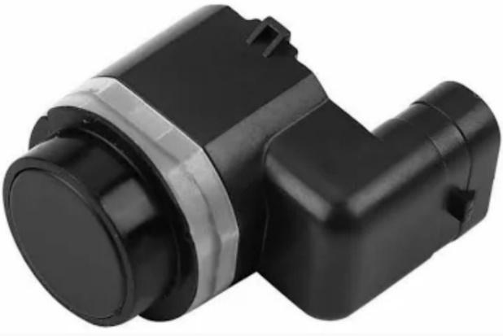

**Figure 6.** PDC Ultrasonic sensor

*Source: alibaba.com, n.d.*

**The PDC Ultrasonic Sensor** provides precise detection capabilities by utilizing ultrasonic technology to accurately measure distances and detect objects in various applications. Traditional parking aids operate based on emitted ultrasound from multiple sensors. When an obstacle is detected, drivers are alerted either visually or acoustically. Installing more ultrasonic sensors across the width of the vehicle enhances measurement accuracy. Depending on the vehicle or system, LED displays, graphic representations on screens, or acoustic signaling devices can provide necessary information (Hella, 2020).

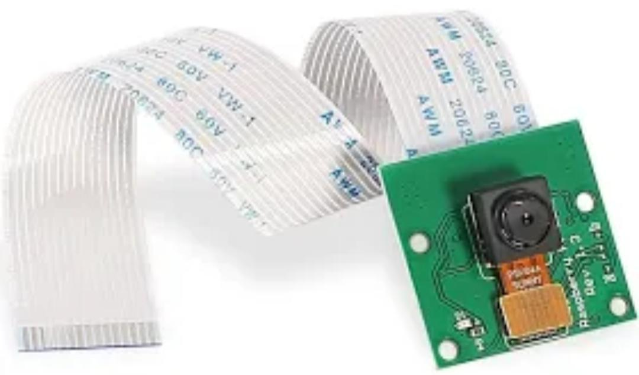

**Figure 7.** Raspberry Pi Camera Module 2

*Source: raspberrypi.com, n.d.*

The Raspberry Pi Camera Module 2, released in April 2016, features an 8-megapixel Sony IMX219 sensor, an upgrade from the original's 5-megapixel OmniVision OV5647 sensor. It captures high-definition video and still photos, is user-friendly for beginners, and offers advanced features for experienced users. It supports various applications like time-lapse and slow-motion, with online examples and bundled libraries for creating effects (*Raspberrypi, n.d.).*

**Figure 8.** Raspberry Pi 4 (Microprocessor)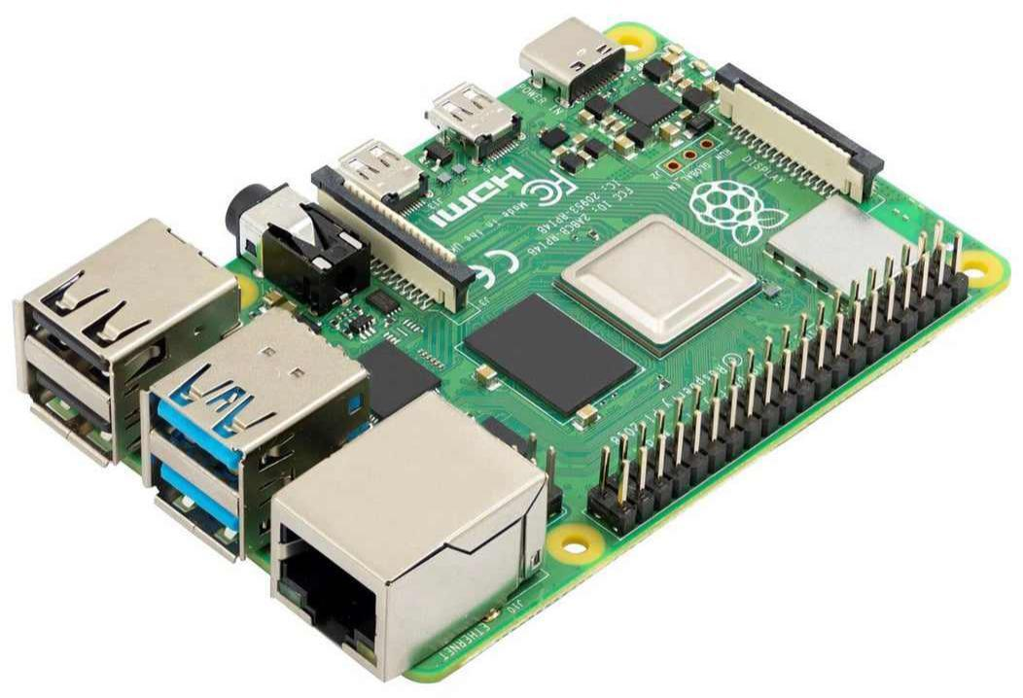

*Source: raspberrypi.com, n.d.*

**The Raspberry Pi 4** is a credit card-sized, single-board computer equipped with a quad-core ARM Cortex-A72 processor, up to 8GB of RAM, multiple USB ports, HDMI output, gigabit Ethernet, and GPIO pins, offering significant computational capability in a compact form factor suitable for a wide range of projects and applications (Raspberrypi, n.d).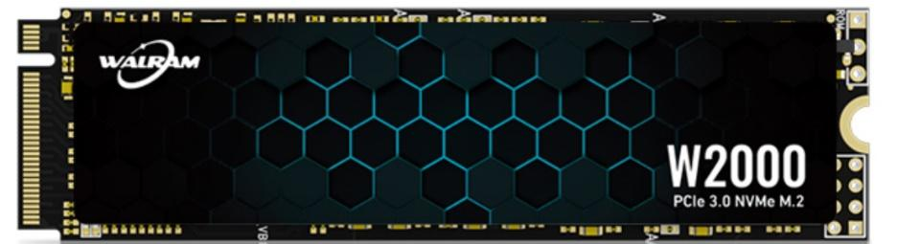

**Figure 9.** M.2 Solid State Drive

*Source: Walram, n.d.*

**An M.2 SSD** is a compact solid-state drive designed for high-performance storage in thin devices like laptops and tablets. Unlike traditional HDDs, SSDs have no moving parts, providing faster and more reliable data storage. M.2 SSDs, smaller than alternatives like mSATA, are particularly valuable for PC or laptop upgrades aimed at gaming, 3D animation, video editing, or large file transfers (Gillis, 2023).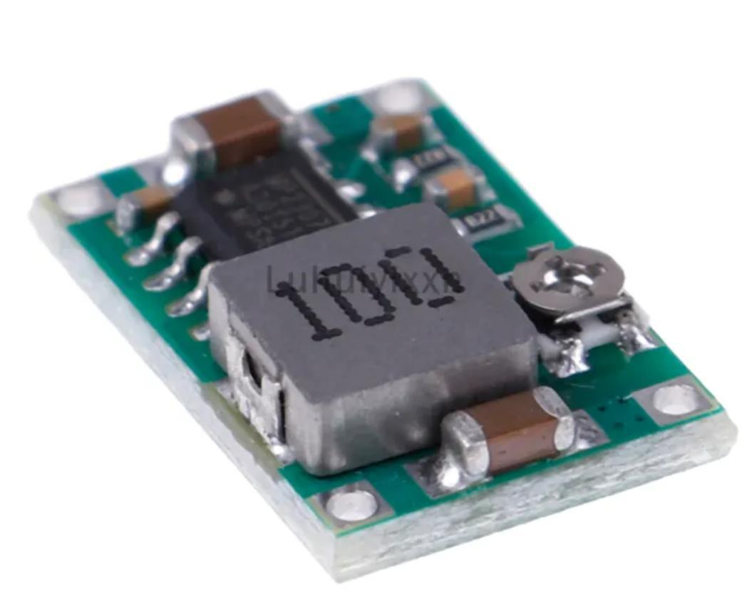

**Figure 10.** DC-DC step down converter volt regulator

Source: lazada.com., n.d.

A buck converter, also called buck regulator or DC-DC step-down switching regulator, is a type of DC-DC converter that provides an output regulated voltage that is lower than its input voltage. (STMicroelectronics, n.d)

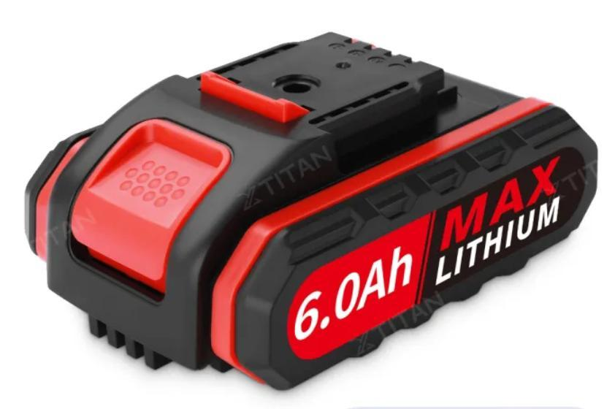

**Figure 12:** *XTitan 6.0ah Lithium battery*

Source: Lazada.com, n.d.

**The XTITAN** Lithium Battery is specifically engineered to be compatible with a range of 188VF tools, including electric drills and reciprocating saws. Lithium battery is an electrochemical device that stores/delivers electrical energy through a reversible intercalation reaction in which Li+ ions are shuttled between two dissimilar electrode materials separated by the Li+ ion conducting electrolyte solution. Featuring a high-capacity 6.0Ah five-cell design, this battery provides extended runtime and consistent power output for various applications (Chowdhury, 2021).

**Methodology for Functionality Testing**

The researcher played a pivotal role in both unit testing and end-to-end testing of the system. Unit testing focuses on assessing the functionality of individual components or modules of the software. This process is crucial for improving instructional techniques, as it emphasizes the importance of precision and quality in software development. Unit testing typically involves invoking specific methods from a programming class to produce observable and automatically verifiable outcomes. This ensures that each part of the software operates correctly in isolation.

End-to-end testing, in contrast, is a more extensive technique used throughout the software development life cycle (SDLC) to evaluate the software's overall functionality and effectiveness in a simulated real-world environment. This type of testing employs data that closely resembles actual user data to create realistic test scenarios. The primary goal of end-to-end testing is to accurately replicate real-world user interactions with the software, thereby ensuring that the software performs reliably and meets all specified requirements when used in a live setting. This comprehensive approach helps identify and rectify potential issues that might not be evident during unit testing, ultimately leading to a more robust and user-friendly software product.

**Table 1.** *Likert Scale Descriptive Rating*

|  |  |  |  |
| --- | --- | --- | --- |
| **Scale** | **Numerical**  **Scale** | **Verbal**  **Interpretation** | **Description** |
| 5 | 4.21-5.00 | Highly  Acceptable | This response indicates the system being evaluated is excellent with respect to the attribute addressed. |
| 4 | 3.41-5.00 | Very  Acceptable | This response indicates the system being evaluated is very good with respect to the attribute addressed. |
| 3 | 2.61-5.00 | Acceptable | This response indicates the system being evaluated is barely accepted with respect to the attribute addressed. |
| 2 | 1.81-5.00 | Fairly  Acceptable | This response indicates the system being evaluated is very poor with respect to the attribute addressed. |
| 1 | 1.00-5.00 | Not  Acceptable | This response indicates the system being evaluated is terrible with respect to the attribute addressed. |

## **Software Requirements**

**Table 2*.*** *Software Requirements*

|  |  |
| --- | --- |
| **Software Used** | **Description** |
| **Android Studio** | Android Studio is the official integrated development environment for Google's Android operating system, built on JetBrains' IntelliJ IDEA software and designed specifically for Android development. It is available for download on Windows, macOS and Linux based operating systems (Developers, n.d.). This was used to develop the user interface and integration components for the AI-driven vehicle detection system for cyclists, ensuring a seamless and efficient user experience on Android devices. |
| **FlutterFlow** | FlutterFlow is an open-source framework created in 2019 by Impending to make developing apps with Flutter faster, easier, and more visual. As Flutter gained popularity as an efficient cross-platform development toolkit, FlutterFlow emerged to simplify building mobile and web apps with its robust widget library, pre-built templates, and drag-and-drop visual design (Linkedin, 2023). The researchers used FlutterFlow to streamline the development of the user interface for the AI-driven vehicle detection system for cyclists, enabling rapid prototyping and ensuring an intuitive, user-friendly design. |
| **Jupyter** | Jupyter notebook is the latest web-based interactive development environment for notebooks, code, and data. Its flexible interface allows users to configure and arrange workflows in data science, scientific computing, computational journalism, and machine learning. A modular design invites extensions to expand and enrich functionality (Jupyter, n.d.). The researchers used JupyterLab to develop and test the machine learning models for the AI-driven vehicle detection system. |
| **Python 3.10** | Python 3.10 is the newest major release of the Python programming language, and it contains many new features and optimizations. It is an interpreted, high-level language that supports multiple programming paradigms, including procedural, object-oriented, and functional programming. Python 3.10 brings several new features, improvements, and optimizations to the language. These include the introduction of pattern matching, a new syntax for decorators, improved error messages, and new modules and APIs (Python, 2021). The researchers used Python 3.10 to develop and implement the AI algorithms for the vehicle detection system, taking advantage of its advanced features and extensive libraries to enhance the system's performance and accuracy. |
| **Raspberry Pi OS** | Raspberry Pi OS (formerly Raspbian) is a free operating system based on Debian GNU/Linux and optimised for the Raspberry Pi hardware (the armhf processor architecture). Raspberry Pi OS comes with over 35,000 packages, or pre-compiled software bundled in a nice format for easy installation on a Raspberry Pi. The initial build was completed in June of 2012, but the distribution continues to be active developed with an emphasis on improving the stability and performance of as many Debian packages as possible (Distro Watch, 2024). The researchers utilized Raspberry Pi OS to run the vehicle detection algorithms on the Raspberry Pi 4 microprocessor. |
| **Visual Studio Code** | Visual Studio Code is a free, lightweight, and extensible code editor for building web, desktop, and mobile applications using any programming language and framework. It has built-in support for Git source control, powerful integrations with GitHub, an integrated debugger, and smart code completion with IntelliSense and AI-driven IntelliCode. With over 30,000 extensions and themes in the Visual Studio Code Marketplace, you can customize the editor to fit your needs and style. It supports JavaScript and TypeScript natively and offers extensions for languages like Python, Java, C/C++, C#, Go, Rust, PHP, and more (Microsoft, 2021). The researchers utilized Visual Studio Code to develop and debug the code for the AI-driven vehicle detection system, taking advantage of its extensibility and integrated tools to streamline the development process. |
| **YOLOv5** | YOLOv5 is a model in the You Only Look Once (YOLO) family of computer vision models. YOLOv5 is commonly used for detecting objects. YOLOv5 comes in four main versions: small (s), medium (m), large (l), and extra-large (x), each offering progressively higher accuracy rates. Each variant also takes a different amount of time to train (Roboflow, 2020). |

**Weighted Mean Formula**

Weighted mean is an average calculated by assigning varying weights to several distinct values. Instead of each data point contributing equally to the final mean, select data points bear greater weight than others. If all weights are identical, the weighted mean and arithmetic mean are identical. Weighted mean formulas will be used in the present study (BYJUS, 2021).

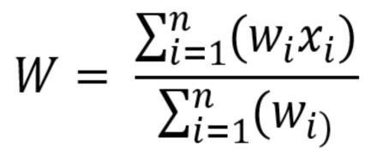

Where:

* W is weighted mean average
* n is the number of terms to be averaged
* wi is the weights applied to the x values
* Xi is the data values to be averaged

Using the weighted mean formula, the researchers would evaluate the parameters to be rated. Each field carries a 25% weight (cyclists) for all fields to be fairly represented. Researchers can calculate the weight by multiplying the average of all the parameters per field by their weight. For each parameter, the average result is added to the other fields.

## **Data Gathering Procedure**

The device assessment questionnaires are scheduled to be distributed to a group of 25 respondents immediately following the completion of the device tests. These questionnaires are an essential tool for the researchers as they collect primary data directly from the individuals who have interacted with the device. The responses gathered from these questionnaires are classified as "primary data," which is data obtained firsthand from direct sources. One of the key advantages of primary data is its timeliness and relevance; since it is collected directly from the participants at the moment of or shortly after their experience with the device, the information is both current and directly applicable to the study at hand. This up-to-date and relevant nature of primary data allows researchers to identify specific tendencies and patterns in the respondents' feedback, providing valuable insights that can inform further development and improvements of the device.

## **Evaluation Tools**

**Table 3.***Functionality of the Device Overview of the Device Assessment Questionnaire*

|  |  |  |  |  |  |  |
| --- | --- | --- | --- | --- | --- | --- |
| Indicators |  | 5 | 4 | 3 | 2 | 1 |
| Completeness | The set of function covers all the specified task and user objectives. |  |  |  |  |  |
| Correctness | The function provides the correct results with the needed degree of precision. |  |  |  |  |  |
| Appropriateness | The function facilitates the accomplishments of specific tasks and objectives. |  |  |  |  |  |

Legend: Strongly Agree – 5; Agree – 4; Neutral – 3; Disagree – 2; Strongly Disagree – 1

Table 3 presents an overview of the Functional Suitability section of the Device Assessment Questionnaire. This questionnaire is a vital instrument for soliciting feedback from participants regarding the device's functionality. It's specifically crafted to gauge whether the device adequately fulfills its intended functions. Through a Likert Scale Rating system, participants provide their opinions, which will then be meticulously analyzed to assess the device's suitability for its designated purpose. The insights gathered from this assessment are pivotal for comprehending the device's performance and for identifying areas where enhancements may be necessary to optimize its functionality. The findings from this assessment will inform future development efforts aimed at refining the device's features and usability to better meet user needs.

**Table 4.***Usability Overview of the Device Assessment Questionnaire*

|  |  |  |  |  |  |  |
| --- | --- | --- | --- | --- | --- | --- |
| Indicators |  | 5 | 4 | 3 | 2 | 1 |
| Recognizability | User can recognize whether a product or system is appropriate for their needs. |  |  |  |  |  |
| Learnability | A product, or system enables the user to learn how to use it with effective’s efficiency in emergency situations. |  |  |  |  |  |
| Operability | A product, or system is easy to operate control, and appropriate to use. |  |  |  |  |  |
| User interface aesthetic | A user interface enables pleasing and satisfying interactions for the user. |  |  |  |  |  |
| Accessibility | A product or system can be used by people with the widest range of characteristics and capabilities to achieve a specified goal in a specified context of use. |  |  |  |  |  |

Legend: Strongly Agree – 5; Agree – 4; Neutral – 3; Disagree – 2; Strongly Disagree - 1

Table 4 presented the Usability evaluation questionnaire that the target respondents are assigned to fill out. The responses to the form would be analyzed using the Likert Scale Rating, and the information that has been gathered would be utilized to determine the device's usability

## **REFERENCES**

Chowdhury, A. U., Muralidharan, N., Daniel, C., Amin, R., & Belharouak, I. (2021). Probing the electrolyte/electrode interface with vibrational sum frequency generation spectroscopy: A review. Journal of Power Sources, 506, 230173. https://doi.org/10.1016/j.jpowsour.2021.230173

Developers. (n.d.). Retrieved from https://developer.android.com/

Distro Watch. (2024). Retrieved from https://distrowatch.com/table-mobile.php?distribution=raspios

Gillis, A. S., Castagna, R., Raffo, D., & Sliwa, C. (2023, June 28). M.2 SSD. Storage. https://www.techtarget.com/searchstorage/definition/M2-SSD

HELLA. (2020, February 26). Park Distance Control (PDC): a parking aid based on ultrasound. https://www.hella.com/techworld/sg/Technical/Car-electronics-and-electrics/Ultrasound-based-parking-aid-park-distance-control-PDC-56199/

Jupyter. (n.d.). Retrieved from https://jupyter.org/

Kanstrén, T. (2022, March 30). A Look at Precision, Recall, and F1-Score - Towards Data Science. Retrieved February 13, 2023, from https://towardsdatascience.com/a- look-at-precision-recall-and-fl-score-36b5fd0dd3ec

Koehrsen, W. (2021, August 3). Use Precision and Recall to Evaluate Your Classification

Model When Accuracy Isn't Enough. Retrieved February 13, 2023, from https://builtin.com/data-science/precision-and-recall

Linkedin. (2023). Retrieved from https://www.linkedin.com/pulse/what-flutter-flow-complete-guide-no-code-development

Microsoft. (2021). Retrieved from https://apps.microsoft.com/detail/xp9khm4bk9fz7q?hl=en-US&gl=U

Nuttall, B. (n.d.). What is a Raspberry Pi? Opensource.com. https://opensource.com/resources/raspberry-pi

Python. (2021). Retrieved from https://www.python.org/downloads/release/python-3100/

Raspberrypi. (n.d.). Retrieved from https://www.raspberrypi.com/products/camera-module-v2/

Roboflow. (2020). Retrieved from https://www.google.com/amp/s/blog.roboflow.com/yolov5-improvements-and-evaluation/amp/

STMicroelectronics Buck Regulator. (n.d.) Retrieved from https://www.st.com/en/power-management/buck-regulators.html

Thermo Fisher. (n.d.). Retrieved from <https://www.thermofisher.com/ph/en/home/materials-science/battery-research/extrusion-rheology-battery-manufacturing>

Koehrsen, W. (2021, August 3). Use Precision and Recall to Evaluate Your Classification Model When Accuracy Isn't Enough. Retrieved February 13, 2023, from https://builtin.com/data-science/precision-and-recall

Kanstrén, T. (2022, March 30). A Look at Precision, Recall, and F1-Score - Towards Data Science. Retrieved February 13, 2023, from https://towardsdatascience.com/a-look-at-precision-recall-and-fl-score-36b5fd0dd3ec